EXP 09: ANALYSIS OF PHOTODETECTOR NOISE AND SNR USING MATLAB/SCILAB
OBJECTIVES :
1. Analyze the key noise sources in an optical photodetector, namely shot noise, dark current noise and thermal (receiver) noise.
2. Compute the individual and total noise current variances (σ²) across a range of input optical powers.
3. Evaluate the Signal-to-Noise Ratio (SNR) and observe its scaling in the thermalnoise-limited and shot-noise-limited regimes.
4. Calculate the Minimum Detectable Optical Power (Pmin) at SNR = 1 (0 dB). 5. Simulate and visualize photodetector noise and SNR curves using MATLAB.
SOFTWARE USED : MATLAB
PROGRAM:
% Photodetector Noise and SNR Analysis
clc;
clear;
close all;
%% 1. Constants and Input Parameters
q = 1.602e-19;
kB = 1.381e-23;
h = 6.626e-34;
c = 2.998e8;
lambda = 1550e-9;
eta = 0.85;
Id = 5e-9;
T = 300;
RL = 50;
Fn = 2;
B = 1e9;

Pdbm = -60:0.1:0;
P = 10.^((Pdbm-30)/10);
%% 2. Responsivity and Signal Current
R = eta*q*lambda/(h*c);
Ip = R*P;
%% 3. Noise Variances and SNR
var_shot = 2*q*Ip*B;
var_dark = 2*q*Id*B;
var_th = 4*kB*T*B*Fn/RL;
var_tot = var_shot + var_dark + var_th;
SNR_dB = 10*log10(Ip.^2 ./ var_tot);
%% 4. Minimum Detectable Power (SNR = 1)
a = R^2;
b = -2*q*B*R;
cc = -(var_dark + var_th);
Pmin = (-b + sqrt(b^2 - 4*a*cc))/(2*a);
PmindBm = 10*log10(Pmin) + 30;
%% 5. Display Main Results
k = find(abs(Pdbm + 30) < 1e-9, 1);
fprintf('Responsivity R = %.4f A/W\n', R);
fprintf('Thermal variance = %.3e A^2\n', var_th);
fprintf('Dark variance = %.3e A^2\n', var_dark);
fprintf('Shot variance (-30 dBm) = %.3e A^2\n', var_shot(k));
fprintf('SNR at -30 dBm = %.2f dB\n', SNR_dB(k));
fprintf('Pmin (SNR = 1) = %.2f dBm (%.3f nW)\n\n', ...
PmindBm, Pmin*1e9);
%% 6. Test Cases: -50 dBm, -30 dBm and 0 dBm
test_dBm = [-50 -30 0];

for i = 1:length(test_dBm)
Pin_dBm = test_dBm(i);
Pin = 10^((Pin_dBm-30)/10);
I_signal = R*Pin;
shot = 2*q*I_signal*B;
total = shot + var_dark + var_th;
SNR = 10*log10(I_signal^2/total);
fprintf('TEST CASE: POWER (%d dBm)\n', Pin_dBm);
fprintf('Input power = %d dBm\n', Pin_dBm);
fprintf('Signal current = %.3e A\n', I_signal);
fprintf('Shot variance = %.3e A^2\n', shot);
fprintf('Thermal variance = %.3e A^2\n', var_th);
fprintf('Dark variance = %.3e A^2\n', var_dark);
fprintf('Total variance = %.3e A^2\n', total);
fprintf('SNR = %.2f dB\n', SNR);
if SNR < 0
fprintf('Signal is below the 0 dB SNR level.\n\n');
else
fprintf('Signal is at or above the 0 dB SNR level.\n\n');
end
end
%% 7. Graph 1: Noise Variance vs Input Power
figure;
loglog(P, var_th*ones(size(P)), 'LineWidth', 1.5);
hold on;
loglog(P, var_dark*ones(size(P)), 'LineWidth', 1.5);
loglog(P, var_shot, 'LineWidth', 1.5);
loglog(P, var_tot, 'LineWidth', 2);

grid on;
xlabel('Input Power (W)');
ylabel('Noise Variance (A^2)');
title('Noise Variance vs Input Power');
legend('Thermal Noise', 'Dark Current Noise', ...
'Shot Noise', 'Total Noise', ...
'Location', 'best');
%% 8. Graph 2: SNR vs Input Power
figure;
plot(Pdbm, SNR_dB, 'LineWidth', 1.5);
hold on;
yline(0, 'r--', '0 dB SNR');
xline(PmindBm, 'k:', 'Minimum Detectable Power');
grid on;
xlabel('Input Power (dBm)');
ylabel('SNR (dB)');
title('SNR vs Input Power');
legend('SNR', '0 dB SNR', 'Minimum Detectable Power', ...
'Location', 'best');
RESULTS:
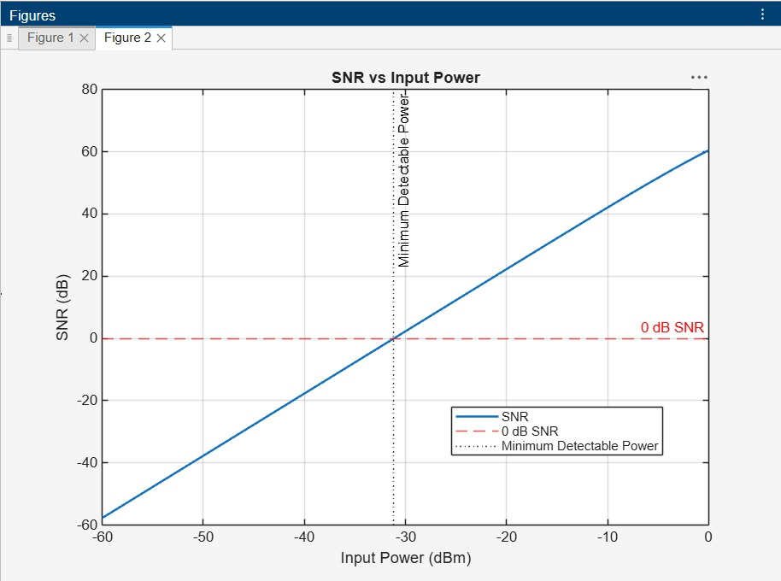
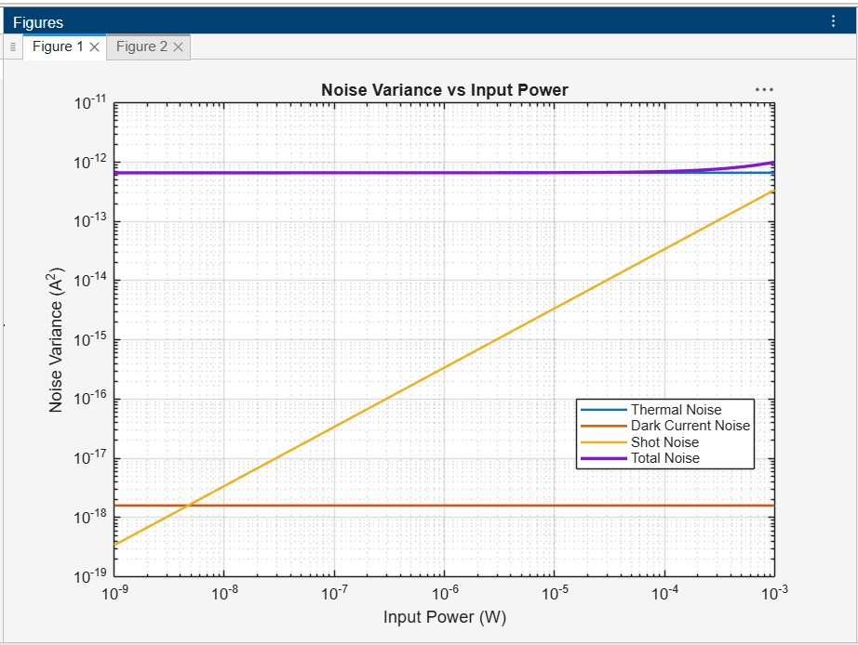
RUBRICS :

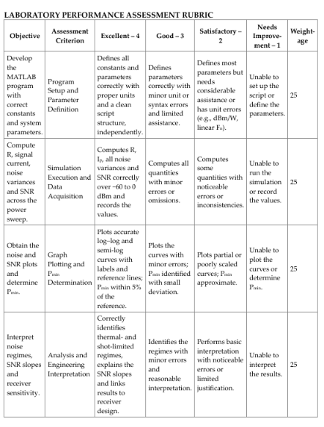
REFLECTION :
I learned to analyze shot, dark-current, and thermal noise in a photodetector using MATLAB and calculate reposivity, SNR, and minimum detectable optical power. I observed how noiseaffects receiver sensitivity and verified that SNR increases with input optical power.
RESULT :
The study shows how input optical power affects noise and SNR in a PIN photodetector receiver. Performance depends on the power level:
• Low power: thermal noise dominates, giving negative SNR and no reliable detection (below Pmin ≈ −31.16 dBm).
• Moderate power: the signal rises above the thermal noise and the SNR increases at 20 dB/decade.
• High power: SNR becomes large and shot noise grows linearly, approaching the thermal level near +2.9 dBm.
These results help in estimating the receiver sensitivity and in designing low-noise optical receivers.

